

 |  | FED
 |  | DSA-2
 |  | p. swethanagasri
 |  | SURABHI ANUSHKA
 |  | 2520090168
 |  | CSIT
 |  | CO-4



In this case study, we developed a Java-based incident priority management system for the CivicEye – Smart City Incident Monitoring & Response System. The system sorts incident reports based on their priority levels to ensure that critical incidents are handled first by emergency response teams.

Using Java, we implemented the Counting Sort algorithm to arrange incident priorities efficiently. Since the priority values are limited to a small range, Counting Sort provides faster performance compared to comparison-based sorting algorithms.

The system helps city administrators quickly identify high-priority incidents such as accidents, fire emergencies, and public safety threats, enabling faster response and better resource allocation.

Implementation Details:
- Created an array to store incident priority levels.
- Identified the maximum priority value.
- Created a counting array to store frequency of each priority.
- Counted occurrences of all priority levels.
- Reconstructed the sorted array using the counting array.
- Displayed incident priorities in sorted order.
- Verified the correctness of sorted results.
- Improved incident handling efficiency through priority-based sorting.

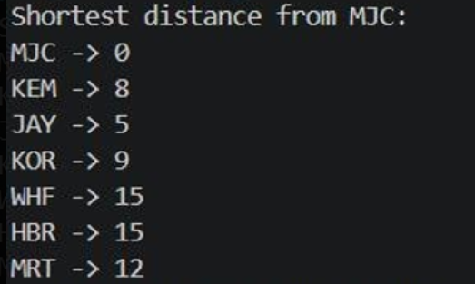

TimeComplexity:
  - Bellam-FordAlgorithm:O(VxE)
  - Here:V=7;E=11
  - Totaloperations=7*11 =77

SLA Analysis:
Total Incidents = 7 Maximum Priority Level = 5
Sorting Technique = Counting Sort Sorting Order = Ascending
Stable Sorting = Yes
Time Complexity = O(n + k

